Maquina virtual Algoritmos

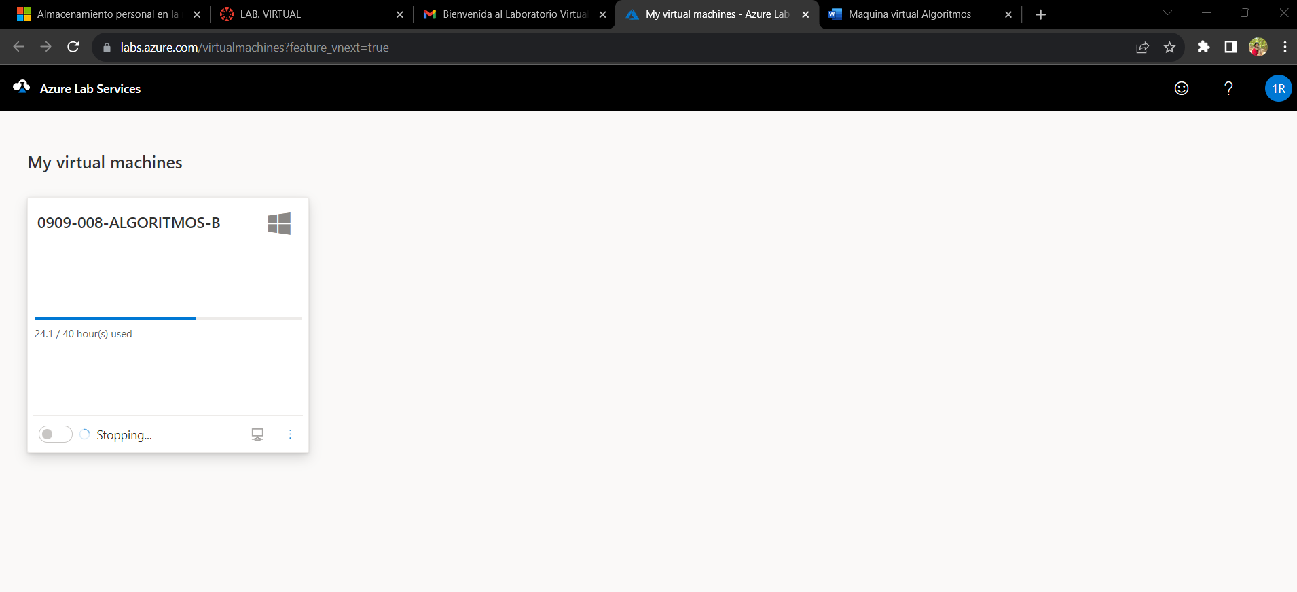

Video Virtual Box

[Presentación 3.mov](https://umgt-my.sharepoint.com/:v:/g/personal/achorosajevr_miumg_edu_gt/ETQsQLXdwc1Hh2F-qjqjRSkBXy6aFV9r8ntISua-I9xIUA?e=PuGi2N&nav=eyJyZWZlcnJhbEluZm8iOnsicmVmZXJyYWxBcHAiOiJTdHJlYW1XZWJBcHAiLCJyZWZlcnJhbFZpZXciOiJTaGFyZURpYWxvZyIsInJlZmVycmFsQXBwUGxhdGZvcm0iOiJXZWIiLCJyZWZlcnJhbE1vZGUiOiJ2aWV3In19)

<https://umgt-my.sharepoint.com/personal/achorosajevr_miumg_edu_gt/_layouts/15/stream.aspx?id=%2Fpersonal%2Fachorosajevr%5Fmiumg%5Fedu%5Fgt%2FDocuments%2FPresentacio%CC%81n%203%2Emov&nav=eyJyZWZlcnJhbEluZm8iOnsicmVmZXJyYWxBcHAiOiJTdHJlYW1XZWJBcHAiLCJyZWZlcnJhbFZpZXciOiJTaGFyZURpYWxvZyIsInJlZmVycmFsQXBwUGxhdGZvcm0iOiJXZWIiLCJyZWZlcnJhbE1vZGUiOiJ2aWV3In19&ga=1&referrer=StreamWebApp%2EWeb&referrerScenario=AddressBarCopied%2Eview>